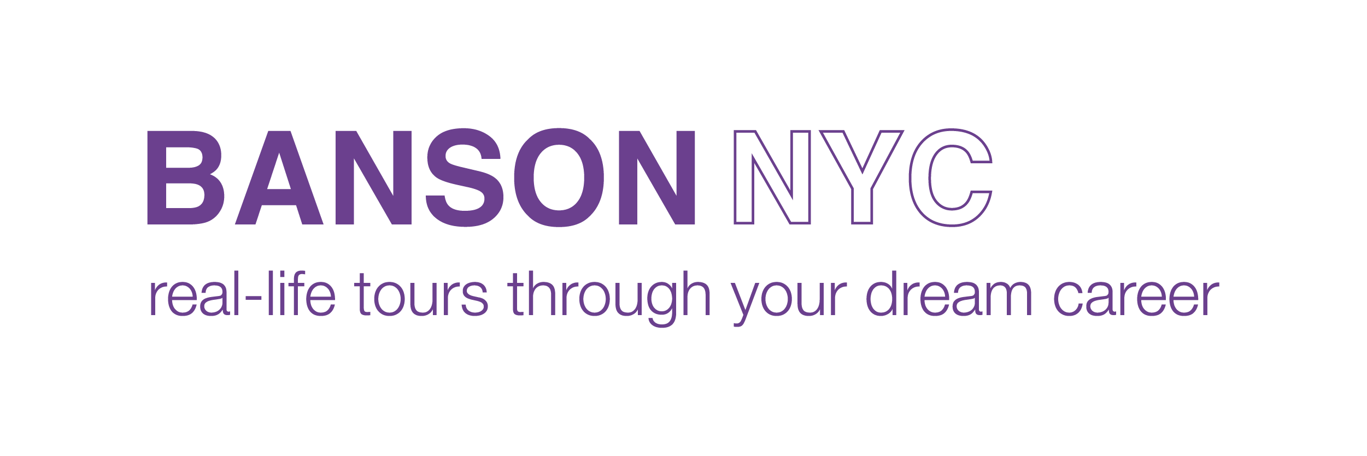
NYC Fashion Summer Camps for High School Students…

Banson NYC is excited to offer 2 In-Person NYC Fashion Summer Camps for high school students in 2023. They are designed for teens entering 9th through 12th grades. Each week-long session will teach students the fundamentals of the fashion industry by providing an insider’s perspective. Students will stay at a hotel in Times Square. All rooms have double occupancy, have 24-hour security, a Resident Advisor, private bathrooms and flat screen TVs. Our camps run from 9:00 am – 5:00 pm Monday-Friday so check in will be between 12:00 – 3:00 pm on Sunday and check out will be at 10:00 am on Saturday. We accept applications on a first come, first served basis. Tuition includes the following;

- 6 Nights in Times Square Hotel
- Visits to Key Players in the Industry
- Attend Interesting Fashion-Related Seminars and Lectures
- Participate in an Educational Shopping Trip
- Visit a Well-Known NYC Museum to See a Current Fashion Exhibit
- Attend an Information Session at a NYC Fashion College
- Participate in a Photo/Video Shoot in Central Park with a Professional Fashion Photographer and Receive a Video of the Experience after Camp
- Group Dinners on Monday, Tuesday and Wednesday Nights
- Manicure / Pedicure Treatment on Thursday Night
- Lunch on Final Day of Camp
- MetroCard for Duration of the Camp
- Enjoy the Excitement of NYC!

The cost is $2075.00 per student or $1875.00 per student if you register with a friend.

Session A: June 18, 2023 – June 24, 2023
Session B: July 9, 2023 – July 15, 2023

For More Information: Contact Banson NYC at www.bansonnyc.org or (917) 328-1469.

