OSU Path to Carbon Neutrality DRAFT
Introduction
After signing the Carbon Commitment in 2007, Oregon State University in 2009 selected a target carbon neutrality date of 2025 and took immediate steps to reduce greenhouse gas (GHG) emissions. Between 2008 and 2019, OSU reduced total emissions 12% (figure 1), and when normalized for enrollment and building growth, the reduction equals 41% per student and per square foot of building space (figure 2). OSU recently implemented an energy policy, a green building policy and has taken other steps to systemically address carbon emissions. Most notably, climate change and sustainability are integral to OSU’s mission, and Strategic Plan 4.0 includes carbon reduction as an institutional priority.
Actions since signing the Carbon Commitment have included installing 10 acres of solar arrays, construction of the OSU Energy Center and adopting updated construction standards. Further actions and increased investment are necessary to continue and accelerate carbon reduction efforts. These further actions require careful prioritization meshed with resourcing and a deliberate plan of action.
The OSU Path to Carbon Neutrality strengthens OSU’s Carbon Commitment and updates the university’s 2009 Climate Plan by outlining and prioritizing direct and indirect actions the university must take to achieve carbon neutrality in 2025, or soon thereafter.
Direct Actions to Reduce Emissions
Accounting for constraints like construction timing, space for new renewable energy technologies and non-renewable energy from regional grids, OSU can achieve at least 34% in direct emissions reduction in the next ten years or fewer with a number of direct actions, requiring an additional investment of approximately $1.5 million per year for 10 years. Planned investments include:
- Deep energy efficiency in existing buildings via heating and cooling tune ups (also included in SP 4.0) and upgrades, lighting upgrades, heating and cooling schedule refinement, etc.
- Enhancement funds to ensure capital projects optimize designs to reduce water use, energy use and long-term maintenance.
- Transportation and land use planning that aims for a drive alone rate for the Corvallis campus of no more than 20%.
- Strategic investments in solar equipment at properties across the state.
These investments have numerous co-benefits including reduced operating and maintenance costs, improved student engagement and retention, more comfortable buildings, increased reliability for research activities, and positive public relations.
Indirect Actions to Reduce Emissions
Indirect emissions reductions fall into two categories: 1) new renewable energy generation the university does not own (like a new wind turbine or a solar farm), and 2) purchases of renewable energy certificates (RECs) or carbon offsets from existing resources that cause incremental change in the carbon marketplace.

New projects can come from partnerships with local utility companies, national energy providers and others via long-term contracts. The Sustainability Office has engaged Pacific Power, NW Natural and others to explore options for long term (typically 5-10 year) purchase agreements for renewable energy, potentially aggregating with other Oregon consumers to reduce cost.
While carbon offsets and RECs offer a more immediate solution, they do not address university preference for new renewable energy generation systems coming online as a result of university action.
What Happens in 2025?
By investing in the prioritized list of actions in Table 1, direct emissions can drop 15-20% by 2025 and around 35% by 2030, likely more. Purchase agreements for renewable energy could be in place by 2025, reducing emissions another 20% or so.
In 2025, the university could choose to purchase carbon offsets to address some or all remaining emissions, tapering off reliance on offsets over time. This portfolio of immediate and meaningful capital investment combined with third-party partnerships and carbon offsets is becoming a common approach among leading institutions in the United States. One example is American University in Washington, D.C., which achieved carbon neutrality in 2018 by purchasing green power and carbon offsets. According to their 2020 STARS report, American University purchased 30,723 tons of carbon offsets to achieve carbon neutrality. It is projected OSU would need to purchase 70,000-80,000 tons of offsets per year starting in 2025 to achieve carbon neutrality, costing around $600,000 per year.
OSU Path to Carbon Neutrality
OSU can reach the carbon neutrality commitment by 2025 by following the below direct and indirect actions, building on policies and systems developed over the past ten years.
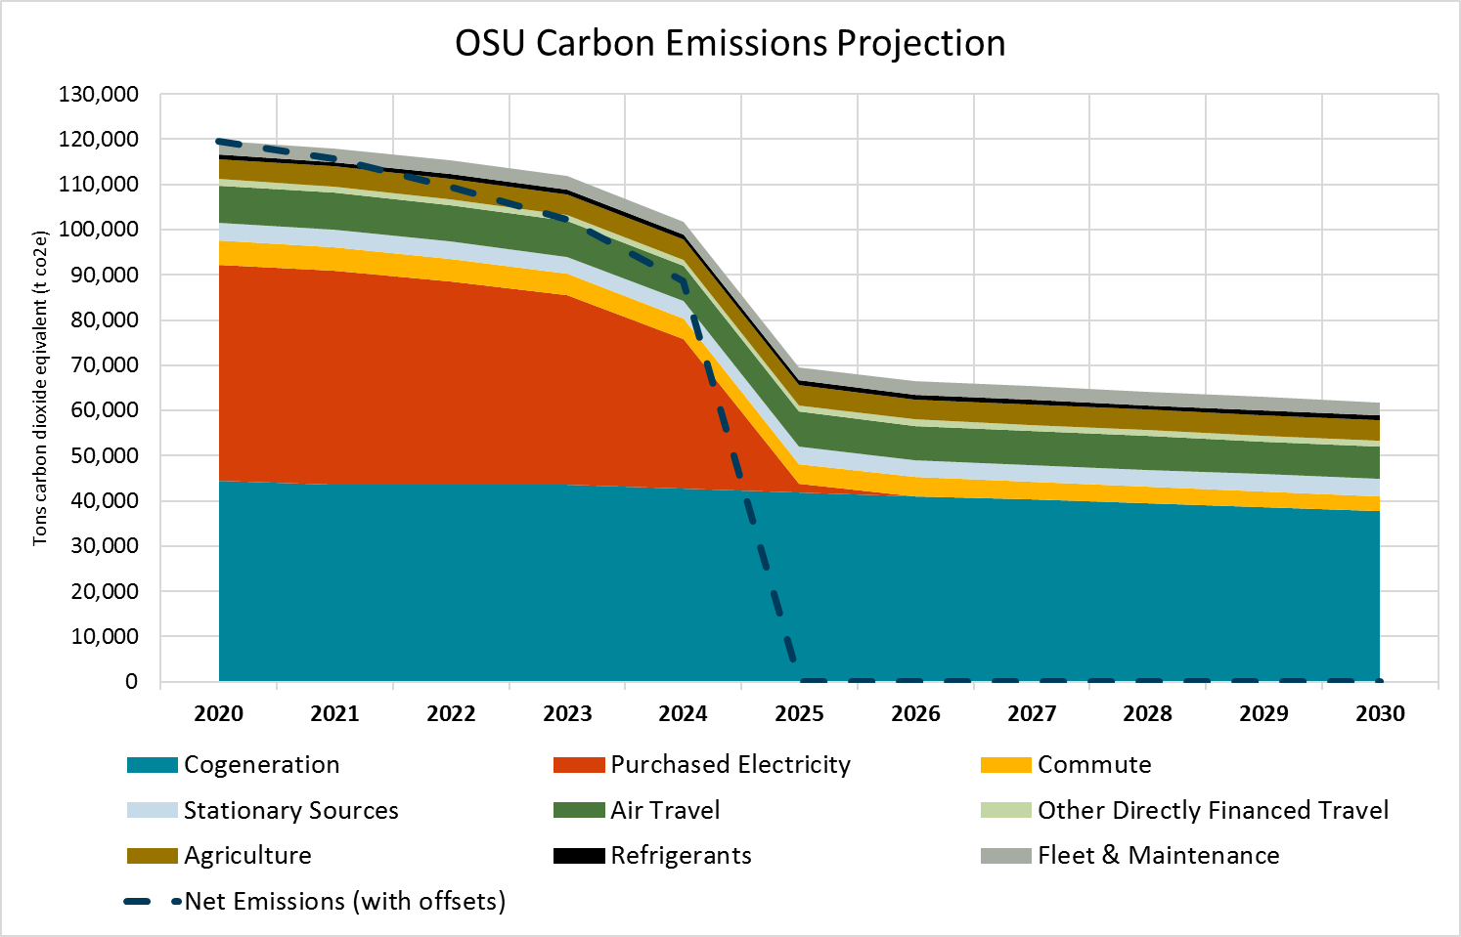
Figure 1: Projected OSU emissions under a 2025 carbon neutrality scenario

Table 1: Carbon Reduction Actions, Estimated Annual Costs and Impacts
Action Priority | Action | Description | % Carbon Reduction | Estimated Marginal Cost | Source of Funds | Funding Status
1 | Improve Existing Building Efficiency | Increase building efficiency by implementing heating and cooling tune ups and calibration, known as retrocommissioning, in at least two existing buildings per year on an ongoing basis. | 16% | $ 500,000 | Utility Savings Reinvestment* | Funded
2 | Leverage Capital Improvement and Renewal Projects | Replace and upgrade heating and cooling systems, building controls, lighting and other aging and failing systems to improve energy efficiency in existing buildings. | 9% | $ 500,000 | Capital Improvement and Renewal | Funded
3 | Expand On-site Renewable Energy | Install solar electrical equipment on two to four university properties per year for 10 years. | 6% | $ 1,000,000 | Revenue Bond | Funded
4 | Decarbonize Major Capital Projects | Include deep energy efficiency and decarbonization in Major Capital Projects. Prioritize renovation over building new, whenever possible. Evaluate hybrid work opportunities to reduce needed building space. | 5% | $ 500,000 | Capital Forecast | TBD
5 | Purchase Off-site Renewable Energy | By 2025, increase proportion of university electricity use from off-site renewable sources to 100%. | 17% | $ 150,000 | Operating Funds | TBD
6 | Implement Sustainable Transportation Strategy | By 2030, implement Sustainable Transportation Strategy to address commute emissions. Encourage alternatives to air travel. | 5% | $ 1,100,000 | Multiple | Funded
7 | Engage University Community | Inspire individual and collective actions that reduce carbon emissions with outreach and action campaigns that engage the university community. | 1% | $ 5,000 | Operating Funds | Funded
8 | Decarbonize District Energy Systems | Create a plan and timeline to eliminate fossil fuel use at the OSU Energy Center, and in campus district energy distribution systems. | TBD | TBD | TBD | TBD
9 | Purchase Carbon Offsets | Prioritize direct emissions reduction as much as possible. Phase out over time use of market-purchased carbon offsets for remaining emissions, possibly in favor of offsets created by university assets. | 41% | $ 600,000 | Operating Funds | TBD
 |  | Total Annual Investment | 100% | $ 4,355,000
 |  | Unfunded Actions |  | $ 1,250,000

* Possible annual scale up to supplement existing $900,000 Utility Savings Reinvestment (USR)

Action 1
Improve Existing Building Efficiency
Goal: increase building efficiency by implementing heating and cooling tune ups and calibration, known as retrocommissioning, in at least two existing buildings per year on an ongoing basis.
SP 4.0 connection: Evaluate return on investment and develop a plan for increasing the retrocommissioning of existing buildings.
Opportunity
Most OSU buildings have automated control systems to schedule and monitor heating and cooling. Malfunctioning controls can result in simultaneous heating and cooling, comfort issues and other issues that severely impact energy use. Since buildings represent over 75% of OSU’s measured carbon emissions, and heating and cooling drive the majority of energy use for most buildings, substantial financial and carbon savings—often exceeding 25%—can be achieved by optimized controls. Financial payback is typically two to six years.
The estimated marginal cost for this action is $500,000 and will be funded from the Utility Savings Reinvestment Fund. This action will lead to 16% reduction in total carbon.
Current State
University Facilities, Infrastructure and Operations (UFIO) has begun a small scale retrocommissioning program addressing one building approximately every two years, limited by existing staffing levels.
Planned and Future Actions
- Planned: add two additional staff in the Facilities Services Building Controls Shop in 2022 to focus on proactive energy efficiency measures.
- Planned: utilize newly established Reserve Fund to capture financial savings from completed projects, and use it to fund future projects and offset some labor costs.
- Future: reinvest additional utility savings to expand program as funding allows.

Action 2

Project example

Gilbert Addition Retrocommissioning
- Project cost: $200,000
- Funding source: Utility Savings Reinvestment Fund
- Completion year: 2022
- Carbon reduction: 200 tons/year

Action Timeline
Short

Complimentary Actions
Capital Improvements and Renewal Projects (Action 2)

Lead
Sustainability Office and Facilities Services

Leverage Capital Improvement and Renewal Projects
Goal: replace and upgrade heating and cooling systems, building controls, lighting and other aging and failing systems to improve energy efficiency in existing buildings
Opportunity
As building systems age and degrade, performance and energy efficiency suffer. This is particularly true with heating and cooling systems, as well as their controls. Additionally, some older buildings lack automation and other features that allow for efficient operation.
The estimated marginal cost for this action is $500,000 from Capital Improvement and Renewal funds. This action will lead to approximately 9% reduction in total carbon.
Current State
The university’s Facilities Renewal Initiative seeks to decrease the backlog of deferred maintenance and aging systems on the Corvallis campus. The FRI began in FY18 and will, over a decade, replace building systems that are failing or are highly inefficient.
Project example
Energy Center Steam Turbine
Project cost: $3M
- Details: The Energy Center uses a natural gas turbine plus a steam turbine to generate steam and electricity for the Corvallis campus. When steam demand fluctuates, some energy is lost due to the existing steam turbine’s inability to respond quickly. Upgrading the steam turbine to one that is more responsive will allow it to produce more electricity.
- Funding Source: Student Leadership and Involvement (SLI) Sustainability Revolving Funds and E&G Capital Improvement and Renewal funds (CIR)
- Completion year: 2022
- Carbon reduction: 3,700 tons/year

Action Timeline
Short to Medium

Complimentary Actions
Existing Building Efficiency (Action 1)
Off-site Renewable Energy (Action 6)

Leads
Capital Planning and Development,
Facilities Services

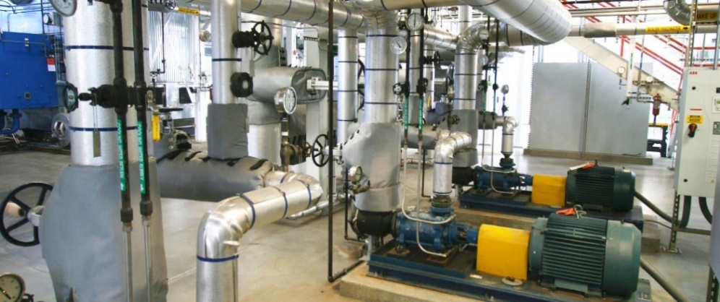

Action 3
Expand On-site Renewable Energy
Goal: install solar electrical equipment on two to four university properties per year for 10 years
Opportunity
Photovoltaic (solar electric) energy represents the best on-site renewable energy resource for most OSU properties. Full buildout of solar on suitable roofs can provide between 5% of the energy needed for a complex, multi-story lab building to over 100% of the energy needs for simpler low-rise buildings.
The estimated marginal cost for this action is $1,000,000 from revenue bonds and will lead to 6% reduction in total carbon.
Current State
OSU gets around 3% of its electricity from on-site solar, mostly from five ground mounted systems owned by Tesla. With only one large rooftop system (at the Student Experience Center), there are many opportunities for additional sites across the state. A 2020 solar assessment has informed OSU's Solar Development Plan, which indicates at least six megawatts of added solar is feasible in fewer than 10 years, enough to power around 600 homes.
Planned and Future Actions
- Planned: in 2022, utilize a power purchase agreement to access federal tax incentives and install at least one new solar electric system.
- Future: utilize power purchase agreement model on 2-4 projects per year, including some Major Capital Projects.

Project example
Campus Operation Center Solar
- Project cost: $600,000
- Projected proportion of building electricity from solar: 100%
- Funding source: OSU revenue bonds
- Carbon reduction: 380 tons/year
Action Timeline
Short to Medium

Complimentary Actions
Major Capital Projects (Action 5)
Off-site Renewable Energy (Action 6)

Lead
Sustainability Office

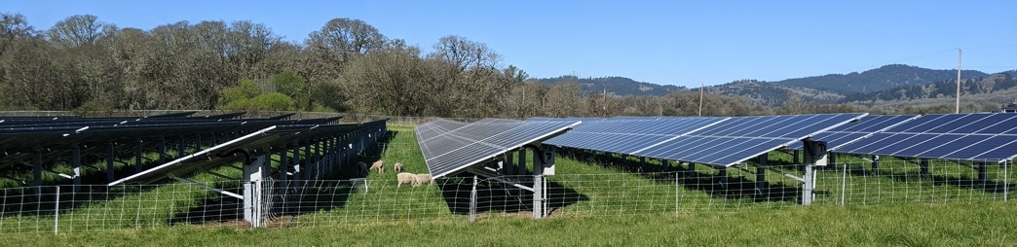
Action 4
Decarbonize Major Capital Projects
Goal: include deep energy efficiency and decarbonization in Major Capital Projects. Prioritize renovation over building new, whenever possible. Evaluate hybrid work opportunities to reduce needed building space.
Opportunity
Adding premium efficiency equipment, renewable energy systems and electrification measures during new construction and major renovations is the most effective way to achieve deep energy efficiency and leverage existing funding sources. Conditions can severely limit options to retrofit equipment and systems after the fact, and by enhancing funding for decarbonization projects in the 10 Year Capital Forecast, efficiencies can be both more extensive and cheaper. This is particularly true for major renovations, which represent the vast majority of work in the 10 Year Capital Forecast. Additionally, since buildings represent over 75% of OSU’s measured carbon emissions, improved space management and more hybrid (on site and remote) work can help reduce emissions by “right sizing” OSU’s space needs, delaying or eliminating the need to add square footage.
The estimated marginal cost for this action is $500,000 from a funding source to be determined. This action will lead to at least 5% reduction in total carbon.
Current State
The Corvallis Campus Vision prioritizes renovation over building new, whenever possible. Capital projects increase energy efficiency but often cannot reach ultra-low or no carbon status. Adding measures to decarbonize buildings will increase project first costs but reduce operating costs over the life of a building. We estimate a 4% to 5% building cost premium reaching minimum decarbonization goals in OSU’s Requirements for Sustainable Development. Deeper energy savings and carbon reduction will be evaluated.
For more information, please see the Ten Year Capital Forecast.
Project examples

LaSells Stewart Center roof & heating/cooling upgrade
- Project cost: $6M
- Funding source: State and E&G Capital Improvement and Renewal funds (CIR)
- Completion year: 2022
- Decarbonization features: energy use 20% below code
- Carbon reduction: 100 tons/year

Arts & Education Complex
- Project cost: $500,000
- Funding source: OSU revenue bonds designated for Carbon Neutrality Projects in the Capital Forecast
- Completion year: 2024
- Decarbonization features: rooftop solar array, energy use 29% below code, designed for full electrification (no natural gas) in the future via high efficiency heat pumps and other measures

Action Timeline
Medium to Long

Complimentary Actions
On-site Renewable Energy (Action 3)
University Community Engagement (Action 8)

Lead
Capital Planning and Development

Action 5
Purchase Off-site Renewable Energy
Goal: by 2025, increase proportion of university electricity from off-site renewable sources to 100%
SP 4.0 connection: Develop funding and contracting pathways that increase proportion of university energy use that is renewable
Opportunity
By combining OSU’s purchasing power with that of other large electrical consumers in Oregon—and entering into multi-year purchasing contracts—the university can cost effectively access energy from regional renewable sources. Models like Portland General Electric's Green Future Impact have paved the way for this type of purchasing arrangement in Oregon.
The estimated marginal cost for this action is $150,000 from a funding source to be determined. This action will lead to 17% reduction in total carbon.
Current State
OSU purchases from Pacific Power around 60% of the electricity needed for its operations. The other 40% comes from the OSU Energy Center. Over 55% of Pacific Power’s electricity comes from burning coal, which emits twice as much carbon dioxide as natural gas. Pacific Power’s long-range plans reduce the amount of goal in their grid mix, but OSU is currently in discussions with them about accelerating this transition through consumer choice, similar to PGE’s Green Future Impact program.
Planned and Future Actions
- In 2021, continue conversations with Pacific Power and others as necessary to establish a renewable energy purchasing contract by 2025 that sources new, regional renewable resources.

Lead
Sustainability Office

Project Cost
Approximately $150,000

Funding Source
Operating funds from Energy Operations

Action Timeline
Medium to Long

Complimentary Actions
On-site Renewable Energy (Action 3)
District Energy Decarbonization (Action 9)

Action 6
Implement Sustainable Transportation Strategy
Goal: by 2030, implement OSU’s Sustainable Transportation Strategy to address commute emissions. Encourage alternatives to air travel.
Opportunity
With the recent launch of the 2030 Sustainable Transportation Strategy (STS), the university has committed to reduce drive-alone commute trips to the Corvallis campus by one-third, from 30% to 20%. The STS includes bold actions that, when implemented together, will reduce OSU’s total carbon emissions by around 2%. The actions will make it easier to choose more sustainable methods of commuting on a daily basis and will decrease total commuter-related greenhouse gas emissions, foster positive relationships with the community, and preserve land for open space, education, and research. Regarding air travel, the COVID-19 pandemic has taught us new ways to engage without flying. Maintaining digital engagement and encouraging careful and selective use of air travel for select university activities, will be critical in reaching OSU’s emissions goals.
The estimated marginal cost for this action is approximately $1.1 million with funding from multiple sources. Action 6 will lead to 5% reduction in total carbon.
Current State
Emissions from the current 30% drive-alone rate for the Corvallis campus account for about 6% of the university’s total emissions. Historically, air travel creates around 11% of OSU’s total carbon emissions.
Planned and Future Actions
Please see the Sustainable Transportation Strategy for a full list of projects and more detail.
Action Timeline
Short to Medium

Complimentary Actions
Existing Building Efficiency (Action 1)
University Community Engagement (Action 8)

Lead
Transportation Services

Project example
Campus Mobility Hub
- Project cost: $400,000
- Funding source: State grant funding (external)
- Completion year: 2023
- Decarbonization features: improved connection between multiple transit systems and bike/pedestrian amenities

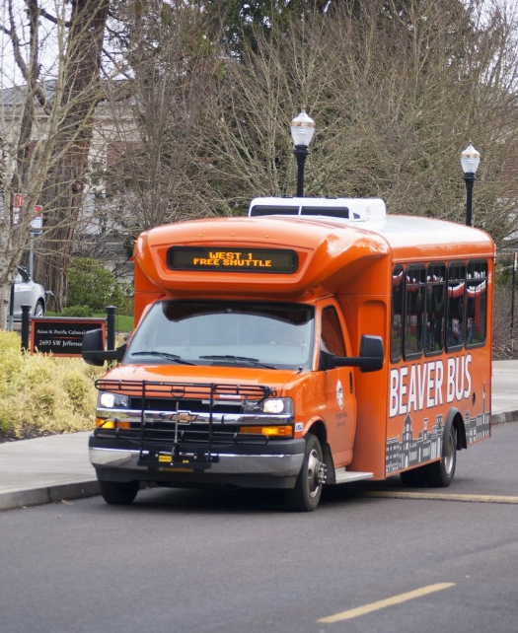

Action 7
Engage University Community
Goal: inspire individual and collective actions that reduce carbon emissions with outreach and action campaigns that engage the university community
SP 4.0 connection: Conduct annual outreach and action campaigns to engage the university community in individual and collective actions that reduce carbon emissions.
Opportunity
Each member of the university community has a role to play in reducing carbon emissions. Through a combination of collective action and centralized investments outlined in this plan, significant carbon savings can be reached, and more resources leveraged for further work.
The estimated marginal cost for this action is $5,000 from operating funds. This action will lead to 1% reduction in total carbon.
Current State
In partnership with the Faculty Senate Carbon Commitment Committee (C3), the Sustainability Office plans to hold or support at least one university wide forum or campaign each academic year. In 2021, Provost's Office, C3 and Sustainability Office co-hosted “Carbon Neutral OSU: What You Can Do” to reengage the university community in the Carbon Commitment. Additionally, the residence hall Eco-Reps program hosts an energy competition between the residence halls each year and the Sustainability Office’s Green Certification programs offer numerous ways to measure and advance sustainability at the unit level, as well as in the Greek community. Student organizations, including the Associated Students of OSU, are also engaged in promoting campaigns and action to students.
Planned and Future Action Examples
- Planned: Continue annual Eco-Rep energy reduction competition, known as the Kilowatt Crackdown.
- Planned: Support Faculty Senate Carbon Commitment Committee periodic campaigns and initiatives that engage the university community in direct action.
- Future: More widely market Green Certifications and similar programs throughout the university community, adding participation or achievement incentives.

Action Timeline
Short to Medium

Complimentary Actions
Sustainable Transportation Strategy (Action 7)

Lead
Faculty Senate Carbon Commitment Committee (C3)
Sustainability Office

Action 8
Decarbonize District Energy Systems
Goal: create a plan and timeline to eliminate fossil fuel use at the OSU Energy Center, and in campus district energy distribution systems
Opportunity
Centralized or “district” energy distribution systems offer higher potential efficiencies and greater flexibility for large organizations like university campuses. In recent years, some universities like Stanford and Texas A&M have shifted away from steam systems like that at the Corvallis campus, in favor of chilled and heated water distribution. Water distribution systems are lower maintenance, more flexible, more efficient and offer both heat recovery and injection opportunities not possible with steam.
The estimated marginal cost, funding and carbon reduction for this action is to be determined.
Current State
The North District Utility Plant, completed in 2021, offers the first of what could be several interlinked district systems that share heated and/or chilled water. Several smaller “loops” exist in other parts of the Corvallis campus, presenting intriguing opportunities. For example, renovation and re-development of the North Campus Triangle and Engineering district is planned to be served from the large and expandable chiller plant in Kelley Engineering Center. This "mini” district already serves Kelley and Johnson Hall with piping and valves ready to expand to other buildings.
Future Actions
- Planned: Renovated and new buildings planned in the Capital Forecast will have systems that integrate with energy efficient, reliable and cost-effective district energy systems.
- Planned: Begin long range planning (15-20 years) to determine the future of OSU’s energy distribution systems.
- Future: As more “mini districts” are established on the Corvallis campus, add major infrastructure (such as piping and conduits under roadways) that allow future flexibility to tie in larger districts.

Action Timeline
Study: short; Implementation: long

Complimentary Actions
Major Capital Projects (Action 5)

Lead
Capital Planning and Development

Action 9
Purchase Carbon Offsets
Goal: Prioritize direct emissions as much as possible. Phase out over time purchases of third-party-certified, regional carbon offsets for remaining emissions,
Opportunity
Carbon offsets offer an immediate but indirect solution to reducing greenhouse gas emissions. Although an ongoing added expense, local offset products support actions in the Pacific Northwest and elsewhere that reduce global warming and send a market signal about the value of carbon. For emissions not practical to eliminate in the short term, like Energy Center natural gas consumption and air travel, offsets offer a “bridge” solution that can be implemented quickly, flexible in scale and reduced over time.
The estimated marginal cost for this action is $600,000 from operating funds. This action will lead to up to 41% reduction in total carbon.
Current State
OSU purchases a small amount of carbon offsets and renewable energy certificates (RECs) annually to offset emissions from some travel through an opt-in program for business travelers, and to offset electricity use in selected buildings. Renewable energy purchases are typically specific to buildings seeking green building certification, or at the direction of students.
Planned and Future Actions
- Planned: continue promoting to OSU units opt in programs for travel offsets and targeted REC purchases.
- Planned: monitor carbon offset and REC regional and national pricing, evaluating appropriate purchase volume on a year-by-year basis.
- Planned: engage with College of Forestry, College of Agricultural Sciences and others regarding opportunities for internal carbon offset programs.

Action Timeline
Medium to Long

Complimentary Actions
All

Lead
Sustainability Office

Project example
Winston Creek Project
- Achieves greenhouse gas reduction by extending the rotation age of forest stands.
- Price per offset ton: $10-$12

Supporting Documentation

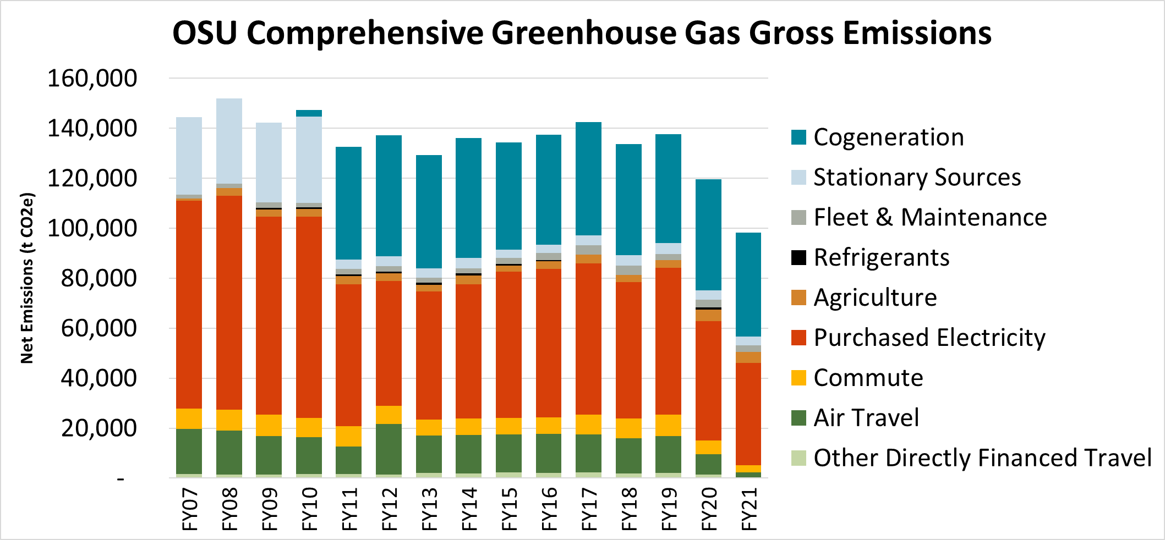
Figure 2: Oregon State University greenhouse gas emissions trend

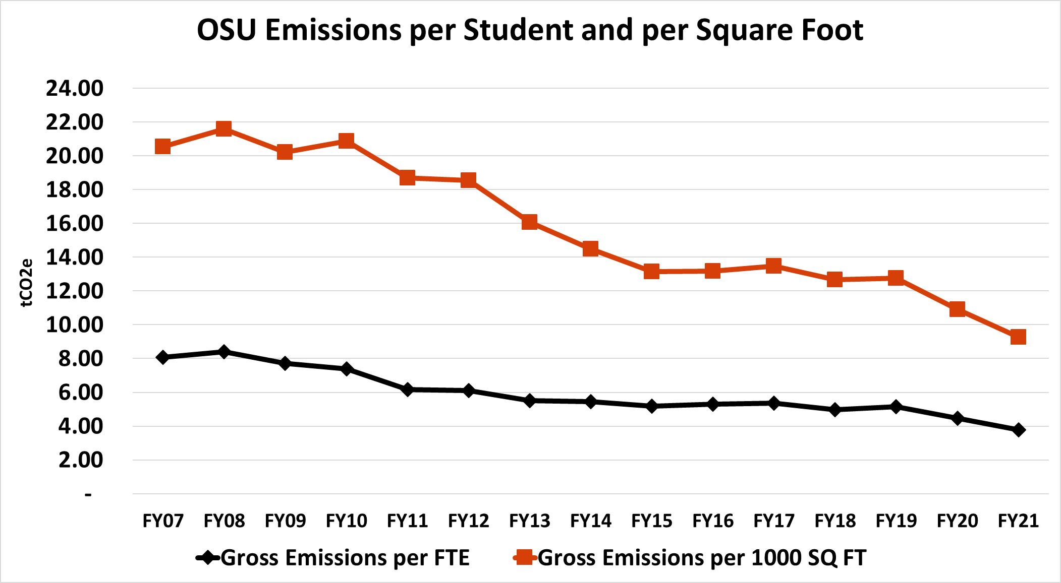
Figure 3: Normalized emissions per FTE student and per square foot of building space

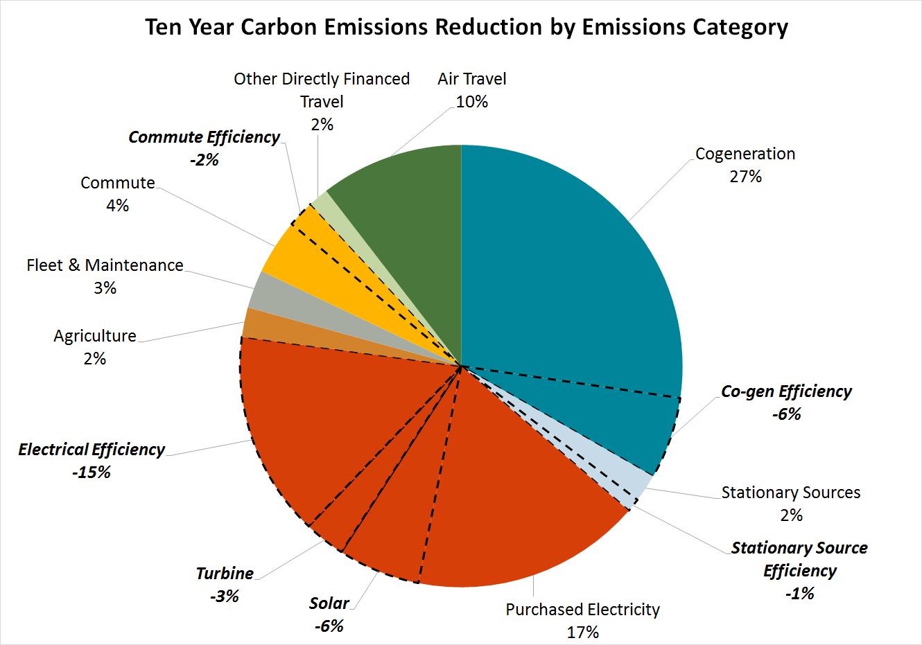
Figure 4: Direct emissions reductions (shown bolded) with enhanced investment of ~$1.5M/year

External Influences
- OSU’s reliance on non-renewable natural gas is significant. Although highly efficient, the OSU Energy Center runs on a fuel for which few renewable substitutes exist at scale. Renewable fuels markets are tapped. University Facilities, Infrastructure and Operations is prioritizing a gas-free future by including options for several Major Capital projects, such as the Arts and Education Complex, to be heated only with electricity in the future.
- Energy efficiency and solar reduce energy cost escalation uncertainty in the context of state or federal carbon pricing. These same measures improve disaster resilience and help the institution adapt to a changing climate.
- The university’s main electrical utility currently generates over 55% of its power from coal. According to PacifiCorp's 2019 Integrated Resource Plan, a substantial shift to lower carbon electricity sources will take more than 10 years.

