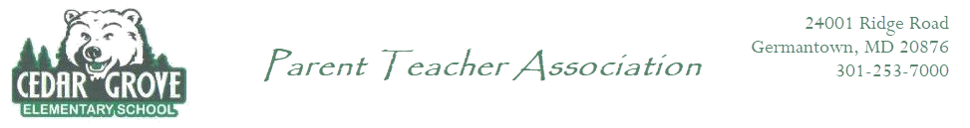

PTA General Assembly Meeting

Agenda
Date: September 12, 2023
Time: 7:00 PM - 8:00 PM
Join Zoom Meeting
Meeting ID: 812 1389 9154
Passcode: 030869

- Call to Order - 1 minutes
- Meeting Procedures - 5 minutes
  - Basic Parliamentary Procedures via Robert’s Rules of Order
  - Quorum minimum - 10 attendees
  - Must be a PTA Member to Vote
  - Meeting Agenda - 1 minute
- Welcome - 10 minutes
  - Officer Introduction/Report out
    - President - Kavita Patel
    - VP of Communication - Jessica Lorey
    - VP of Committees/Membership - Natasha Dotrang
      - Introduction of Chairs
        - Spirit Wear (Anna Bieniek)
        - Book Fair (Colby James, Gaby Rojas)
        - Welcome Back Bash (Jessica Lorey, Kate Mahoney)
        - Fall Festival (Nehall Gutierrez)
        - Silent Auction/Spirit Nights (Debi Voiner)
        - Penny Wars (Ina Choi, Jennifer Wong)
        - Bingo Night (Georgia Anderson)
        - Winter Wonderland (Nicole Saltzman)
        - Holiday Shop (Janet Remsnyder, Stacy Lederer, Mimi Cao)
        - Read-a-thon (Jessica Lorey)
        - Family Paint Night (Pranita Shrestha Shakya)
        - Staff Appreciation (Jessica Lorey)
        - STEM Night (Kavita Patel, Jessica Lorey)
        - Yearbook (Tashina Singh)
        - ASD (Binnish Mustafa)
        - Volunteer Coordinator (Gaby Rojas)
        - Classroom Parent (Jennifer Wong)
      - Upcoming/Current Events
        - Book Fair (Colby James, Gaby Rojas)
        - Welcome Back Bash (Jessica Lorey, Kate Mahoney)
        - RESCHEDULED: Movie Night (October 7th)
        - Silent Auction/Spirit Nights (Debi Voiner)
        - Fall Festival (Nehall Gutierrez)
        - Penny Wars (Ina Choi, Jennifer Wong)
      - Vacancies
        - Around The World Night
        - End of Year Bash
    - Secretary - Anna Bieniek
    - Treasurer - Ivy Doss
      - Budget Approval - 15 minutes
        - Proposed Budget 2023-2024
- Principal’s Report - 5 minutes
- Staff Liaison Report - 5 minutes
- New Business - 5 minutes
- Next Meeting November 7th, 2023 7:00 PM
- Adjournment

