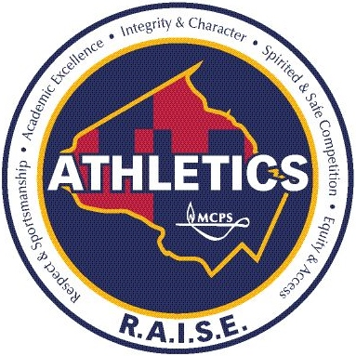

MCPS ATHLETICS
RETURN to R.A.I.S.E.
2nd Semester and Fall Season Information

MCPS Community,

Following is information regarding the second semester operations of the Montgomery County Public Schools (MCPS) high school interscholastic athletics program, along with registration information for the fall season. To begin, all in-person programming and activities would only be conducted if health metrics allow and in alignment with guidelines and protocols designated by the COVID-19 Task Force for MCPS Athletics. Such guidelines are included in the Return to R.A.I.S.E. Strategic Plan, <link> and comply with guidelines and recommendations released by the Centers for Disease Control and Prevention, Maryland State Department of Education (MSDE), Maryland Public Secondary Schools Athletic Association (MPSSAA), and Montgomery County.

Additionally, in-person programming will be optional for coaches and student-athletes. As a result, program offerings will be school and team-specific, depending on the selection of coaches and the interest of student-athletes. Program operations will be confirmed in the coming weeks, as schools finalize their options and registrations are received from student-athletes.

Finally, it is important to note that in-person programming will begin with conditioning and skills-based practices/tryouts, which must occur for a minimum of 20 calendar days (starting with the first practice) prior to any contests or competition, per MPSSAA regulations. Competition and contests may not occur, if health metrics do not allow. Activities will be conducted in-person to the extent possible throughout the semester, pending health metrics and necessary approval. A preliminary framework of operations will be provided by February 13, and a confirmed operations plan will be provided by February 23, 2021.

Second Semester Overview

An overview of the second semester of operations for MCPS Athletics is provided in the Second Semester Return to R.A.I.S.E. Plan. <link> The plan outlines the calendar and timeline for each season, as well as provides a brief overview of operations. More detailed information regarding the spring season and winter sports will be provided later in the semester. MCPS Athletics will focus now on the administration of the fall sports season, in conducting in-person programming to the extent possible.

Fall Season Registration

The fall season, per the Maryland Public Secondary Schools Athletic Association (MPSSAA) calendar, runs from February 13 through April 17, 2021 (the start date for the MCPS fall season is February 27, 2021). MCPS will open registration for the fall season on Friday, January 29, 2021. Registration will remain open through February 22, 2021. Registration will close on this date to allow coaches with the opportunity to group students appropriately and for coaches and schools to plan program operations. Parents/guardians and student-athletes should review the following information and resources prior to registering, in order to understand program logistics. While final operations and metrics are still unknown, these resources provide an overview of the second semester experience.

MCPS Athletics Resources

The following resources are available for students and parents/guardians regarding the operations of the MCPS athletics program. All documents, information, and guidance are subject to change, based on the ever-changing dynamics of COVID-19. <link all>:

- Second Semester Plan – provides an overview of the second semester of operations
- Return to R.A.I.S.E. Strategic Plan – provides the operating procedures and protocol that will be used during the fall season. This is a fluid document and will be updated, as guidelines and recommendations change.
- Return to R.A.I.S.E. Video – this video provides an overview of the protocol and procedures in the Return to R.A.I.S.E. Strategic Plan. The video was filmed in late-October–guidelines and procedures may change, per state and local recommendations.
- COVID-19 Athletics Information Webpage – all information regarding the return of in-person programming is available here; updates will continue to be posted on this site.
- ParentVue Registration Information – resources for students and parents/guardians when completing the registration process.

In closing, we are committed to providing the greatest and safest experience for student-athletes, coaches, and stakeholders across MCPS Athletics during the second semester and beyond. More information will be provided in the coming weeks and throughout the semester. Specific questions should be directed to your school’s athletics specialist (AD) or coach. We look forward to welcoming our student-athletes and coaches back on campuses in the near future, as we continue to support the mental, physical, and social-emotional well-being of student-athletes and champion the R.A.I.S.E. core values of MCPS Athletics!

Sincerely,

Jeffrey K. Sullivan, Ed.D.

Director, Systemwide Athletics

