

**“Start at Home”:**

**Testing What Works to Advance Employee Financial Well-being**

# 

# Grant Application

June 2020

## Background:

Financial health and financial well-being go far beyond traditional financial education efforts. The [Financial Health Network](https://finhealthnetwork.org/research/financial-health-measurement/) describes financial health as arising “when your daily systems help you build resilience and pursue opportunities.” Similarly, the [Consumer Financial Protection Bureau](https://files.consumerfinance.gov/f/documents/201709_cfpb_financial-well-being-in-America.pdf) (CFPB) defines financial well-being “as having financial security and financial freedom of choice, in the present and in the future. [This includes]: control over your day-to-day, month-to-month finances; financial freedom to make choices to enjoy life; capacity to absorb a financial shock; and being on track to meet your financial goals.”

The COVID-19 pandemic has underscored the vast scope of consumers’ financial fragility. Before the pandemic, research showed that [78% of workers](http://press.careerbuilder.com/2017-08-24-Living-Paycheck-to-Paycheck-is-a-Way-of-Life-for-Majority-of-U-S-Workers-According-to-New-CareerBuilder-Survey) lived paycheck to paycheck, [37%](https://www.federalreserve.gov/publications/files/2019-report-economic-well-being-us-households-202005.pdf) would have difficulty coming up with $400 in the event of an emergency, and consumers immediately increased their total out-of-pocket healthcare spending by 60% in the week after receiving a tax refund. In 2017, the [Foundation’s own research](https://www.ncuf.coop/files/Foundation_Financial_Health_Check-Up_Aggregation_slides_for_publication_2017_11_05.pdf) showed that more than half (58%) of credit union members were struggling financially. [1] These numbers will not improve as the unemployment rate soars to [15.8%](https://www.cnn.com/2020/05/08/economy/april-jobs-report-2020-coronavirus/index.html) and the economy falls into recession.[2]

Several bodies of research[3] have examined how employers, including credit unions, can improve their employees’ financial well-being as a talent retention tool and training tool to better serve their consumer-members. Among credit unions alone there are over 300,000 full-time equivalent employees, including thousands of frontline workers, such as tellers, loan officers and branch managers. As reflected in the graphic below from Filene, there is a great demand for and need in the employee space to foster financial well-being. Concern about finances can diminish employees’ productivity and affect long-term physical and mental health.

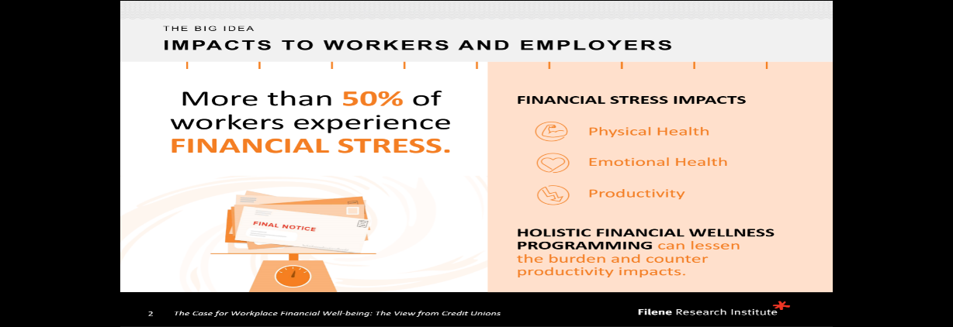

This grant effort seeks to increase credit union employee financial well-being through one discreet savings initiative: **Building short term savings through split deposit**. “Splitting” a direct deposit is the ability to automatically direct a fixed percentage or dollar amount of pay into a savings or investment account.

The overarching goal of this grant effort is tohave impact -- specifically to **rigorously test this evidence-based intervention that has strong potential to build financial resilience among credit union employees and to be scaled within and across credit unions.**

**Minimum requirements:**

The Foundation is looking for credit unions with **at least 250 employees** and researchers who are willing to collaborate with each other to effectuate the goals of this grant effort. Credit unions and researchers can apply by using the links below. Once applications are received, assessed and approved, the Foundation will invite researchers and credit unions to a webinar to assess the most appropriate pairing of researchers and credit unions.

This grant effort will run through 2021. Total funding (research and credit union) of up to $100,000 is available in calendar year 2020. A similar funding commitment is anticipated to be approved by the Foundation board later this year as part of the Foundation’s 2021 grant cycle budget.

## Expectations of applicant credit unions and researchers

Timing of grants:

Grants will be funded in August 2020 and work must be completed by **December 31, 2021**.

Acceptance/Rejection Process

The Foundation will review all applications for each credit union’s financial capacity and commitment to improving financial well-being that directly support the stated objectives defined in this application. Similarly, the Foundation will review all applications from researchers for researchers’ experience, bandwidth and ability to conduct the specific savings initiatives outlined above. The Foundation may schedule discussions with you if it becomes necessary to clarify elements of your application. Credit union and researcher participation in this project will be based upon the applications the Foundation determines best satisfy its objectives for this project. The Foundation also reserves the right to reject any and/or all applications received.

Instructions for Responses to Application

Please provide your responses to the questions outlined in attached Adobe Acrobat (pdf) form. Failure to provide requested materials with your response may be cause for rejection of the proposal.

Due Date of Proposal

The deadline for applications is close of business on **July 29, 2020**.

Where to Send Your Application

Please save a copy of the pdf application below and once completed, please email it and any supporting documentation to Danielle Brown, Engagement Director, National Credit Union Foundation at [dbrown@ncuf.coop](mailto:dbrown@ncuf.coop).

Questions

If you have questions while preparing your application, please contact Danielle Brown, National Engagement Director, National Credit Union Foundation at (608) 556-2406 or [dbrown@ncuf.coop](mailto:dbrown@ncuf.coop).

**CREDIT UNION gRANT APPLICATION**



**RESEARCHER GRANT APPLICATION**



1. For more background about the Foundation, go to [www.ncuf.coop](http://www.ncuf.coop)
2. The Congressional Budget Office (CBO) estimates that the unemployment rate will rise to 15.8% in the third quarter of 2020. Source: <https://www.cbo.gov/publication/56368>.
3. <https://finhealthnetwork.org/research/workplace-financial-health/>; <https://filene.org/learn-something/reports/the-case-for-workplace-financial-well-being-the-view-from-credit-unions>.