 |  | College Bulletin
September 28, 2020
- What’s New?  - Scholarships  - College of the Week  - FAFSA  - Virtual visits/Opportunities  - Student Resources  - Teacher Resources  Estimated average scholarship $ per TUSD senior:  $12,611  Average annual cost to attend University of Arizona  $15,594  Scholarship/Financial Aid:  https://www.raise.me/  http://www.collegescholarships.org/financial-aid/  AzCAN (Arizona College Access Network)  Scholarships a-z  FAFSA  ECAP  Metropolitan Education Commission  College Greenlight  College Depot  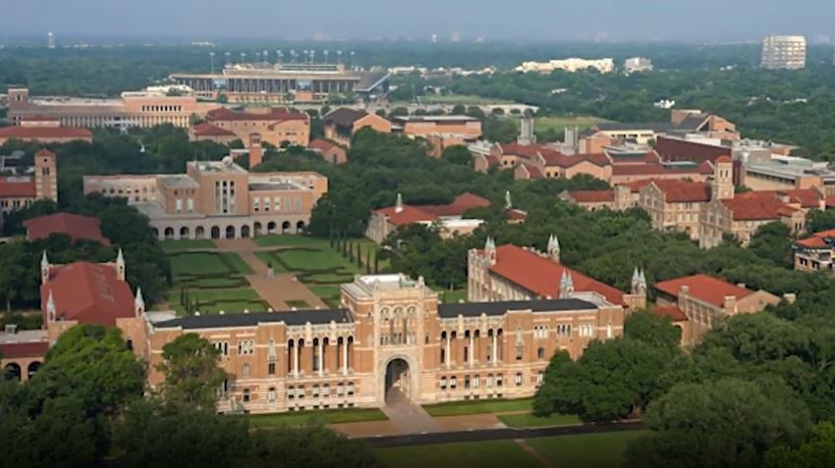  Resource Websites:  How to Write a Strong College Essay  Everfi - Free lessons on finances  Ask the College Expert Youtube series |  | What’s New?  Below are new additions to the College Bulletin. Information has been listed first in the indicated section.  - Raise.me – micro scholarship site – check it out – for students and teachers!  - New scholarships!!!! (Scholarships)  - Arizona College Consortium Virtual College Fair (Virtual Visits)  - Sample college essays that worked! (Student Resources)  - Information for free application to Mount St. Mary’s (CA) and NAU (Student Resources)  All other information previously included in the prior College Bulletins.  Raise.me – various micro scholarships to different schools  NSHSS – various scholarships – Deadline October 1, 2020  https://www.nshss.org/scholarships/  Visionary Scholarship – Deadline May 1, 2021  Grades 9-12 eligible to apply  https://americancollegefoundation.org/college-planning-visionary-scholarship-details/  NHS Scholarship for NHS Members ONLY – Deadline: December 1, 2020  NHS Scholarship Application Overview  Applications for the NHS Scholarship open on Thursday, October 1 for NHS members – please see your NHS advisor.  Mark these important dates on your calendar:  • October 1—Application opens  • December 1—Application closes; adviser verification and all recommendations due  Leadership Enterprise for a Diverse America (LEDA) – December 14, 2020 – FOR JUNIORS  https://ledascholars.org/our-program/leda-scholars-program/recruitment-admissions/apply/  A LEDA Scholar includes a summer college experience, counseling toward college admissions, internship support when in college  2020-2021 application timeline:  September–December 2020: Interested applicants can begin and submit the LEDA Scholars application  December 14, 2020: Final submission deadline at 11:59 PM (PST)  December 2020–April 2021: Applications are reviewed by the Recruitment and Admission team  Late February-March 2021: All applicants are notified about Part I of the process. Applicants moving on to Part II are asked to submit additional materials.  March-April 2021: All Part II applicants are notified and finalists are invited to participate in a video or phone interview.  April-May 2021: All remaining applicants are notified, and 100 LEDA Scholars are admitted to the LEDA Scholars Program.  Questbridge - deadline September 29, 2020  https://www.questbridge.org/  Why should students apply? QuestBridge is a nationally recognized nonprofit that has helped thousands of students gain admission and full four-year scholarships to top colleges through the National College Match. Our 40 college partners are actively seeking students who have excelled academically despite financial hardship, and they partner with us to find these outstanding students.  We are looking for high school seniors who have shown outstanding academic ability despite financial challenges. We take a holistic approach to reviewing applications, and we do not have absolute criteria or cut-offs for GPA, standardized test scores, income, or other factors.  Be sure to review carefully:  Eligibility | Academic Achievement | Financial Qualifications | Personal Circumstances | FAQs  Flinn Scholarship – deadline October 5  https://flinn.org/flinn-scholars/  The Flinn Scholarship isn’t about what you get. It’s about who you become and the impact you make. With the world-class education made possible by the Flinn Scholarship, you can become an agent of discovery, creativity and leadership who will make a difference.  The Flinn Scholarship—valued at more than $120,000—covers tuition, fees, housing, and meals at one of Arizona’s public universities, plus study abroad. Each year, about 20 top high-school seniors are chosen to learn from amazing faculty, business leaders, and civic innovators and join a vibrant, eclectic community—including a powerful alumni network.  What’s the Flinn Scholar blueprint? There is none. Scholars emerge from throughout Arizona and become leaders in every discipline you can imagine.  Golden Door Scholarship – deadline October 25, 2020  https://www.goldendoorscholars.org/apply-now  Scholarship specifically for DACA, TSP or undocumented students.  Deadline not posted yet, you can sign up to get email updates.  Application requirements:  - Your high school and/or college transcript.  - Your class rank and class size if available.  - Information about leadership and extracurricular activities.  - An essay - you can use one written from one of your college applications or use one of the prompts from The Common Application.  Horatio-Alger-Association Scholarship – October 26, 2020  https://scholars.horatioalger.org/scholarships/  Different scholarships available.  Criteria:  Critical financial need ($55,000 or less adjusted gross income per family)  Integrity and perseverance in overcoming adversity  Minimum grade point average (GPA) of 2.0  Participation in community service  United States citizenship  Coca Cola Scholarship - Deadline: October 31, 2020  HS Seniors, the Coca Cola Scholarship application is open. This is a merit-based scholarship and does not require the ACT/SAT for eligibility!  Cokeurl.com/Apply2020  High school seniors, apply today to receive one of 150 $20,000 college #scholarships and join the incredible #CokeScholars family as a member of the 2021 class. Deadline is October 31, 2020, at 5pm Eastern.  Dorrance Scholarship – February 10, 2021  http://www.dorrancescholarship.org/  January 15, 2021 - Have FAFSA submitted (FAFSA will open on October 1)  February 10, 2021 – Phase I Deadline: Online application, transcript and test scores, apply to ASU, NAU, and UA  Scholarship is for UA, ASU or NAU.  The Dorrance Scholarship for first-generation students is a need-based award providing financial and academic support for Arizona high school graduates pursuing an undergraduate degree at one of Arizona’s public universities. The award is renewable for a total of eight semesters (four years) of funding. Scholarships are renewed based on academic standing, participation in program events and activities and community service projects.  Student & Parent Information Sessions (Click on one of the dates to register.)  October 13th at 6:00pm AZ time  October 15th at 6:00pm AZ time (Spanish session)  October 29th at 6:00pm AZ time  College of the Week: Rice University  College: Rice University  Website: www.rice.edu  Location: Houston, Texas  State or Private: Private  Acceptance rate: 16%  Total enrollment (undergraduate): 4,000  Tuition: $64,500  Conference: Division I, C-USA  Mascot: Owls  Financial aid: Rice undergraduates are eligible for The Rice Investment, one of the nation’s most generous financial aid initiatives that increases access to an affordable, quality education for low- and middle-income students. The Rice Investment will provide extraordinary opportunity for extraordinary students to seek a top-tier college education at a time when many families are struggling to make ends meet. Going forward, low- and middle-income families with typical assets will receive scholarships and grants as outlined below:  Family Income Range* The Rice Investment Grant to Include  $65,000 and below Full Tuition, Fees, Room and Board  $65,001 - $130,000 Full Tuition  $130,001 - $200,000 Half Tuition  *Some families may qualify for additional need-based aid beyond The Rice Investment.  The Rice Investment will also reduce the burden of student debt. Beginning in fall 2019, degree-seeking undergraduate students from families with incomes up to $200,000 who qualify for The Rice Investment will no longer be required to take out loans as part of their need-based financial aid packages.  *Also a Questbridge Partner  Academic Highlights  - Students can choose from more than 50 programs of study.  - The student-to-faculty ratio is 6:1.  - The Honor Code at Rice fosters a spirit of freedom, independence, honesty and mutual trust.  - Experiential learning is an important part of education at Rice.  - Advising is available for students pursuing medical school, law school, or business school.  - About 33% of students study abroad.  FAFSA OPENS ON OCTOBER 1st. 2020  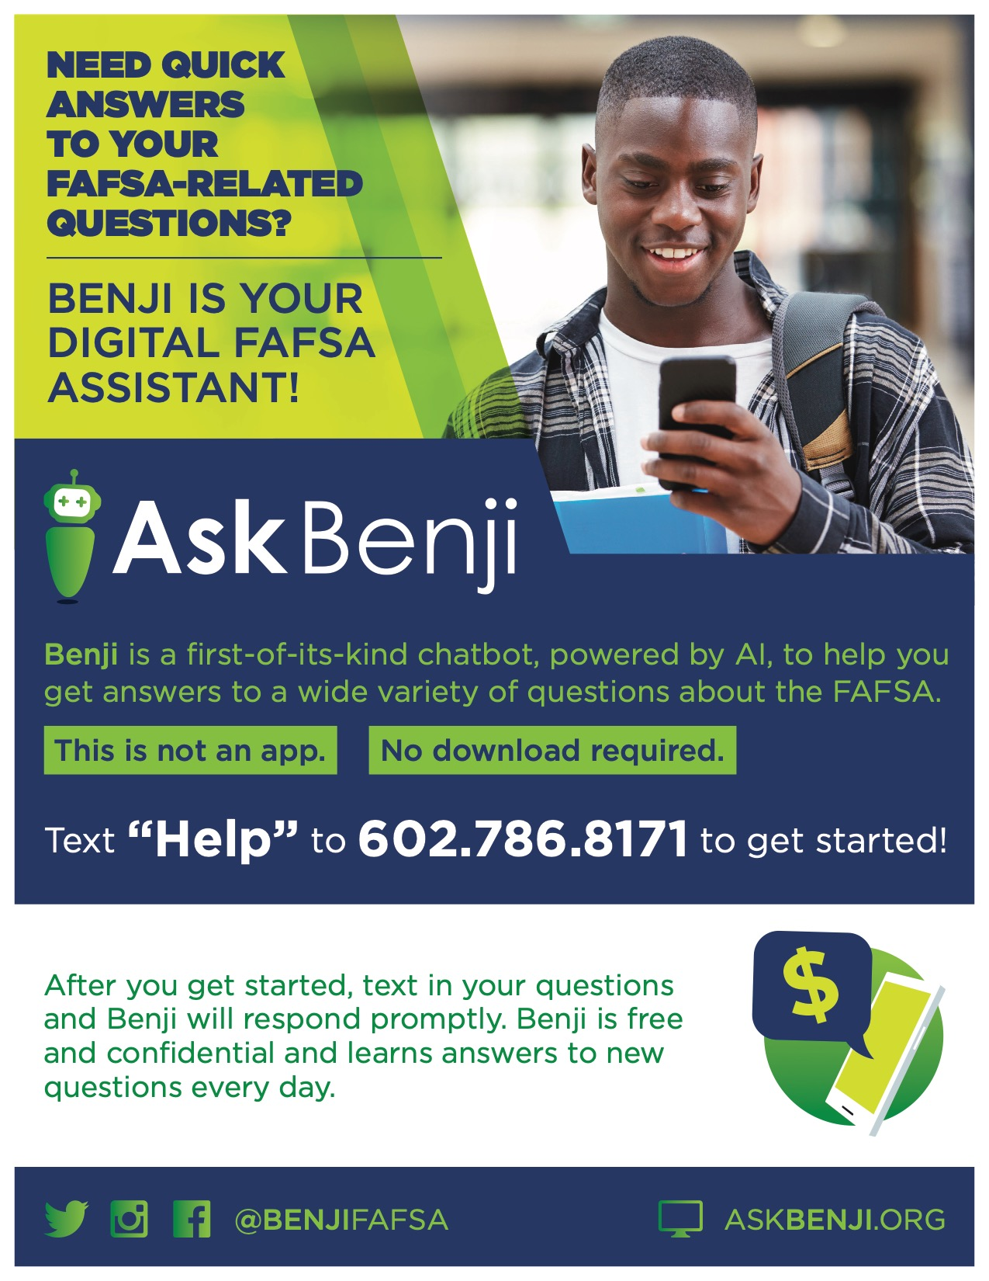  Virtual Visits/Opportunities  THE ARIZONA COLLEGE CONSORTIUM Invites you to the Fall Tour 2020.  Explore over 30 Colleges, Universities, Community Colleges, and other institutions of higher education both in and out of state in one of our free online interactive college fairs, or through your own exploration! DISCOVER THE POSSIBILITIES  Registration for college fairs is FREE for all students. Register and log-in to the fairs at https://virtual.gotocollegefairs.com/azccvirtualfair  College reps. will be available to chat with you during our live interactive College Fairs.  Saturday, September 19 10:00 a.m. – 3:00 p.m. MST  Tuesday, October 27 4:00 p.m. – 8:00 p.m. MST  Tuesday, November 17 8:00 a.m. – 3:00 p.m. MST  - Virtual College Leadership Fair hosted by Army JROTC, Sept. 26th – 10am – 1pm (EST): Virtual College Visit Registration and Info  - List of virtual fly in by College/University: College Fly Ins  - Website for virtual visits to colleges/universities across the country: https://www.youvisit.com/collegesearch/  - College Planning and virtual visits: https://www.coalitionforcollegeaccess.org/  - National College Fairs Virtual - https://www.nacacfairs.org/virtual/  - Virtual events for Amherst, Bowdoin, Carleton, Pomona, Swarthmore and Williams Six Colleges Virtual Fair  Student Resources  Sample College Essays - Johns Hopkins – essays that “worked” for admission to Johns Hopkins University – site also includes Admission Committee comments  Free application for Mount St. Mary’s, Los Angeles, take a look at the website and fill out your application!  https://admissions.msmu.edu/portal/aad  Northern Arizona University - Start your application and include the waiver code #NAU21 it is free!  AP resources  5 tips for Success in AP  50 Ways to Stay Focused While Learning at Home  Pima Community College IRSRC (Immigrant and Refugee Student Resource Center): https://pima.edu/student-resources/support-services/irsrc/index.html  UA Immigrant Resource Center: https://immigrant.arizona.edu/  **Both Centers will present to classrooms.  DACA, undocumented, youth-led resource - https://www.alientoaz.org/  Common app - https://www.commonapp.org/ - student and teacher/counselor resources. 2020-2021 essay prompts are listed.  Collective statement from over 350 colleges and universities  Admission Deans from over 350 colleges and universities have signed onto a collective statement about what they care about – Making Caring Common Project.  They have identified 5 values to show compassion during COVID 19 and strive toward equity.  - Self-care  - Academic work  - Service and contributions to others  - Family contributions  - Extracurricular and summer activities  Detailed explanation of each and the institutions that have signed on can be found here:  https://static1.squarespace.com/static/5b7c56e255b02c683659fe43/t/5ef9bf0b67d0746239a5b429/1593425675919/FINAL+Statement_+TTT+Deans+20200629.pdf  Teacher/Counselor Resources  University of Arizona information for counselors and teachers: https://admissions.arizona.edu/counselor-resources  ACT College and Career Readiness Workshops–  Get the latest information on ACT K-12 tools, PD opportunities, resources  ACT prep information – downloadable kit for teachers. **Many schools are not requiring the ACT this year** Check out: Information on Test Optional and Universities  Materials available at educators.actclub.org/kit  Admissions directors from Dartmouth College, Northwestern University, Princeton University, University of California - Berkeley,  and Vanderbilt University invite you to listen to updates from each of our institutions and get your questions answered.  This invitation is exclusively for counselors who are employed by secondary schools or Community-based Organizations  Wednesday, September 30, 2020  8 a.m. Pacific Time / 11 a.m. Eastern Time  Webinar link sent upon registration.  OR  Thursday, October 1, 2020  1 p.m. Pacific Time / 4 p.m. Eastern Time  Webinar link sent upon registration.  Claremont McKenna College, Haverford College, Colorado College, Kenyon College, Connecticut College, Macalester College, Grinnell College, Sarah Lawrence College will host a virtual counselor/teacher update:  Tuesday, September 29 - 5 pm EDT  Register Here for September 29  Thursday, October 8 - 9 am EDT  Register Here for October 8  Thursday, October 15 - 11 am EDT  Register Here for October 15  Schedule a virtual visit with a UA Admissions team.  Go to: https://slate.admissions.arizona.edu/register/virtualvisits  You can choose from the following:  Class "drop in" greeting - Short hello from your representative. (5 mins)  Admissions 101 (20 mins)  Paying for College (20 mins)  Student Panel: Student Life & Campus Experience (20 mins)  The Honors College (20 mins)  SALT Center (20 mins)  College/Academic Focused Session (20 mins - Check box to display options)  Application Workshop (60 mins)  Resume / Personal Statement Workshop (60 mins)  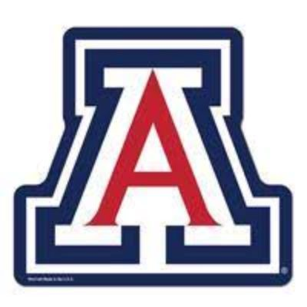  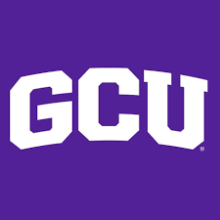Grand Canyon University offers free 45-minute lessons for students to learn about different topics.  If you have questions: Faith Beatty – faith.beatty@gcu.edu  You can find the schedule and options here: https://calendly.com/gculivelessons?month=2020-09  - Global Awareness*  - The goal of this activity is for students to understand why global awareness is essential to the progression of society and to celebrate other cultures. Students can expect to participate in a small-group activity to research countries from across the world, discuss the difference between surface culture and deep culture, and engage with a GCU student throughout the entire activity.  - DISC Analysis*  - Students can expect an activity that will help identify their personality type, analyze their strengths and blind spots, understand how to leverage their strengths in various environments and communicate with different personality types. This activity includes the DISC assessment, small group discussion and a presentation provided by a GCU student.  - Innovative Thinking*  - The objective of this activity is for students to apply creative strategies to develop an innovative mindset. During the activity, students will identify everyday items that can be combined to solve everyday problems and engage with a GCU student throughout the entire activity.  - Interview Prep 101*  - The goal of this activity is for students to gain foundational skills to prepare a resume, execute a successful interview, and utilize tips and tricks to help them stand out from the rest. During the activity, students will work through two handouts and engage with a GCU student about how to relate these topics to the real world.  - Leadership Development*  - The goal of this activity is for students to learn about their leadership style, how to leverage their strengths, and implement their leadership style into their daily life. Included in this activity is a leadership quiz, analysis of leadership styles strengths and blind spots, and engage with a GCU student throughout the entire activity.
Rincon’s College Bulletin
Rincon Students go to College!
Week of September 28, 2020

Many scholarships are available for students. Check out this information so that you can take advantage of the funds that are available to send students to college. New information added regularly.

Websites for Scholarship and Student Loan Searches

www.metedu.org/rcac www.finaid.com www.collegeanswer.com www.scholarshipamerica.org; http://www.scholarshipguidance.com/ www.petersons.com www.azfoundation.org studentscholarships.org www.salliemae.com www.princetonreview.com www.collegeprowler.comhttps://bigfuture.collegeboard.org/scholarshipsearch

UA websites - http://startnow.arizona.edu/http://scholarshipuniverse.com (UA Net ID needed)Scholarships without citizenship requirements http://www.scholarshipsaz.org/scholarships.html

NEW: Tucson Unified School District Scholarship Listing:http://www.tusd1.org/contents/distinfo/scholarships/general.asp**For students interested in Nursing: www.registerednursing.org Note: Beware of scholarship websites with questionable scholarship offers that are primarily designed just to collect your money

***Don’t forget: EVERY Monday is (ZOOM) COLLEGE SHIRT MONDAY!

****Monday October 1 – FAFSA OPENS! www.fafsa.ed.gov

Important AP Information: All AP Students and Parents- As you may remember from last year, the Collegeboard has made changes to the AP registration process, including moving the registration deadline to the fall. The 2020-2021 AP Registration Deadline is Sunday, November 1, 2020. This year ALL payment will be made Online. Students now must pay their $40.00 deposit (or, if you would prefer, pay $95.00 in full, if you do not qualify for Free or Reduced Lunch.) If you DO qualify for Free or Reduced Lunch, you will have a form Online that you will be required to fill out. The student must pay Online for the deposit) by Sunday, November 1st, 2020, for all AP exams you wish to take in the spring. You will NOT be able to register later in the year. The number of tests ordered is based on the deposits we receive by November 1st. More information will follow. For questions please see your AP Teachers, or Mrs. Bacal.

Students: It's never too early to start planning your college career! Please make an appointment to see Mrs. Bacal for a list of things you need to do to get into and to be able to pay for college!

Rincon High School students will graduate with the skills and knowledge necessary for college and career success.

